THIS PAGE CAN BE DELETED FROM YOUR FINAL REPORT
(ALL text in blue can be deleted from your final submission, Text in red should be edited by you)
The following guidelines must be adhered to:

Writing Style
Your report should usually be written from a third person, observational perspective. Do not use the following terms:
Do use or model from the following examples which are written from an observational third person perspective:
"The researcher" or "the observer"  "It was observed that..."  "The data suggest..."  "The experiment revealed..."  "The results show..."  "One can infer that..."  "The study indicates..."  "The findings imply..."  "The evidence supports..."  "An analysis of the data" | "The procedure was executed as follows..."  "The measurements were taken..."  "The subjects/participants behaved in a certain way..."  "The test conditions were controlled..."  "The trends in the data"  "The observations were made by the team."  "The process was documented as..."  "The phenomenon was recorded."  "A statistical analysis was conducted."  "The data were collected and analysed."

Report Layout and Style
The following guidelines must be adhered to:
- All text will be black in the report unless in very exceptional circumstance.
- Main body text must be at least 11pt font using either Arial or Calibri font.
- Main body text will have 1.5 line spacing.
- Margins will be a minimum of 2 cm on each side.
- All pages will be numbered consecutively.
- Start each section on a new page.
- Figures must have captions and be numbered (e.g., Figure 1).
- Tables must have captions and be numbered (e.g., Table 1).
- Figures may be black and white, or colour.
Word Count
- There is a 8,000-word limit for the project. This is a maximum, not a target. Shorter is often better.
- All words in the main body, excluding words in figures and tables, will be included in the word count.
- Consider what can be removed from the main body and placed in an appendix to reduce the word count as not every detail may be necessary in the main document.
Copyright and Intellectual Property Rights (IPR)
Your report should be written considering that it will be within the public domain. Normally, you retain copyright over your written work and Intellectual Property Rights (IPR) over any technical work. There are rare situations where this might not be as simple, for example when working with a company, external client, or on a larger university project. There are strategies you can utilise:
- You can inform your supervisory team that the project cannot be made available to other students undertaking an MSc Project.
- You can provide a shortened report for sharing that does not contain the protected information.
- You can assign IPR to the external collaborator, although you should take great care when doing so. It is best to speak to your supervisor.
- Non-disclosure agreements can be made between the external collaborator and the supervision team.

Bayesian Flight Risk and Efficiency Optimiser:

An AI Approach to Safer and Greener Aviation

By
Osman Ebrahim

Submitted to
The University of Roehampton

In partial fulfilment of the requirements
for the degree of
BACHELOR OF SCIENCE IN COMPUTER SCIENCE

Declaration

I hereby certify that this report constitutes my own work, that where the language of others is used, quotation marks so indicate, and that appropriate credit is given where I have used the language, ideas, expressions, or writings of others.

I declare that this report describes the original work that has not been previously presented for the award of any other degree of any other institution.
Signed: Osman
Osman Ebrahim
Date: 11/01/2026

Acknowledgements

Here it is customary to thank the people who have supported this work and your studies in general. It is up to you who you thank!

Abstract
GUIDANCE: Up to 300 words
A short summary of your project to include the problem, the main literature reviewed, your implementation and your findings.
Write this after you have finished the entire report!
Table of Contents
1. Introduction 9
Problem Statement and/or Research question 9
Aims 9
Objectives 9
2. Background and Context 9
Background 10
Summary of relevant published work (Literature review) 10
Competitor Analysis/ Related work 11
3. Tools and Methods 12
Rationale for the technical tools selected 12
Rationale for the research methods used 12
Project management and Product lifecycle 12
Risk register 13
4. Requirements/Specifications 13
5. Solution design 15
6. Solution implementation 16
7. Solution testing/ evaluation 16
8. Discussion 17
9. Conclusion 18
Summary 18
Recommendations for further work 18
Reflection 18
10. References 18
11. Appendices 19

List of figures

List of Tables

Introduction
Aviation is a safety-critical industry in which operational decisions must be made under conditions of significant uncertainty. Despite major advances in aircraft engineering, regulatory oversight, and pilot training, risks associated with mechanical failure, adverse weather conditions, human performance, and system complexity remain unavoidable. It has been observed that traditional deterministic approaches often struggle to represent uncertainty explicitly, limiting their effectiveness in predicting and mitigating rare but high-impact events. As a result, probabilistic reasoning methods are increasingly being explored to enhance aviation safety analysis.
At the same time, the aviation sector faces growing pressure to reduce its environmental impact. Commercial aviation contributes a notable proportion of global carbon dioxide emissions, particularly during fuel-intensive phases such as climb, holding, and route deviation. The evidence suggests that inefficiencies in flight planning and operational decision-making can lead to unnecessary fuel consumption, thereby increasing emissions. Current industry tools typically address safety and environmental performance separately, despite both being influenced by similar operational factors.
Bayesian inference offers a structured probabilistic framework for reasoning under uncertainty by updating prior beliefs as new evidence becomes available. An analysis of existing research indicates that Bayesian methods have been successfully applied to accident modelling, fault diagnosis, and risk assessment within aviation. However, the integration of Bayesian approaches to jointly consider flight safety and CO₂ emissions remains under-explored. This project is motivated by the need to investigate whether Bayesian theory can support safer and more sustainable aviation decision-making within a unified analytical framework.

Problem Statement and/or Research question
The problem addressed in this study is the lack of integrated analytical approaches that simultaneously assess aviation safety risks and environmental impact under uncertainty. Airline operators, air-traffic management systems, and regulatory bodies are affected by this limitation, as decisions relating to routing, weather avoidance, and operational constraints often involve trade-offs between safety and fuel efficiency. The problem occurs during flight planning and operational decision-making phases, where incomplete or uncertain information can lead to conservative or sub-optimal choices. It is important to address this issue because even small inefficiencies, when scaled across the global aviation network, can result in increased accident risk exposure and significant cumulative CO₂ emissions.

Research Question
How can Bayesian inference be applied to aviation decision-making to improve flight safety while reducing CO₂ emissions?

Aims
- To examine how Bayesian inference can be used to model uncertainty in aviation safety-critical decision-making.
- To investigate the relationship between probabilistic risk assessment and CO₂ emissions in flight operations.
- To evaluate the potential of Bayesian-based models to support safer and more environmentally sustainable aviation practices.

Objectives
- To review and critically evaluate existing literature on Bayesian methods applied to aviation safety and environmental analysis.
- To identify relevant variables influencing accident risk and fuel consumption within flight operations.
- To develop and implement a Bayesian model using appropriate computational tools to analyse safety and emissions outcomes.
- To assess the results of the model and interpret their implications for aviation decision-making.
- To document the development process, methodological choices, and project management activities in line with academic and supervisory requirements.

Background and Context

Background
Commercial aviation operates within a complex socio-technical system in which safety, efficiency, and environmental responsibility must be carefully balanced. Although air transport remains one of the safest modes of travel, accident investigations consistently demonstrate that incidents rarely arise from a single isolated cause. Instead, risk emerges through the interaction of multiple operational and human factors, including adverse weather conditions, aircraft age, maintenance quality, organisational pressure, and decision-making under uncertainty [18]. An analysis of historical accident data suggests that these influences are inherently probabilistic, meaning they vary across conditions and cannot be fully captured through purely deterministic approaches.
Alongside safety, the aviation industry is increasingly challenged by its environmental impact. Commercial flight operations contribute a notable proportion of global anthropogenic carbon dioxide emissions, primarily due to fuel burn during take-off, climb, and cruise phases [15]. Research indicates that operational inefficiencies such as extended routing, holding patterns, and conservative contingency planning may significantly increase fuel consumption and emissions output [16]. As global air traffic demand continues to expand, these inefficiencies create both environmental and regulatory pressures for airlines and governing bodies seeking more sustainable operational strategies [4].
Despite the clear links between operational safety and environmental efficiency, current decision-support tools within aviation typically treat these domains separately. Safety modelling frameworks tend to prioritise accident probability estimation and mitigation, whereas environmental systems focus primarily on fuel efficiency and emissions reduction. This methodological separation limits the ability to understand trade-offs in scenarios where operational decisions simultaneously influence risk exposure and carbon impact. Consequently, there is a growing requirement for integrated analytical approaches capable of accounting for uncertainty while evaluating both safety and sustainability outcomes together.
Bayesian inference provides a probabilistic framework that is well suited to addressing this need. By explicitly representing uncertainty and updating predictions as new evidence becomes available, Bayesian methods align closely with the evolving nature of aviation risk assessment in practice. Prior studies have successfully applied Bayesian approaches to fault diagnosis, reliability modelling, and accident causation analysis [17]. However, the use of Bayesian theory to jointly evaluate accident probability alongside environmental emissions remains limited within existing literature. This project is situated within this research gap, exploring how integrated Bayesian modelling can support safer and more sustainable aviation decision-making through an interpretable and evidence-based AI system.

Context
The context of this study lies at the intersection of aviation safety engineering, environmental sustainability, and artificial intelligence. Regulatory organisations such as the International Civil Aviation Organization (ICAO) and national aviation authorities increasingly emphasise data-driven safety management systems and environmental performance monitoring. At the same time, advances in computational power and data availability have enabled the use of probabilistic AI techniques within safety-critical domains.
Within this context, Bayesian inference has gained attention due to its transparency, interpretability, and ability to incorporate expert knowledge alongside empirical data. Unlike black-box machine learning models, Bayesian systems allow probability distributions and uncertainty intervals to be examined directly, which is particularly important in safety-critical applications. The study is therefore positioned within a broader movement towards explainable and trustworthy AI in aviation.
The work is conducted within an academic setting and focuses on publicly available aviation data sources. The system developed is intended for analysis and decision-support rather than operational deployment. By investigating the combined modelling of accident probability and CO₂ emissions, the study addresses known limitations in existing tools and contributes to ongoing discussions surrounding sustainable aviation and ethical AI use.

Summary of relevant published work (Literature review)

2.3.1 Aviation Safety and Accident Risk Modelling
Aviation safety has historically been addressed through a combination of engineering standards, regulatory oversight, and post-incident investigation. Statistical analyses of aviation accidents indicate that failures rarely occur due to a single cause; instead, accidents emerge from complex interactions between technical, environmental, and human factors. Studies by Reason (1997) and later safety system models emphasise the layered nature of defences in aviation systems, highlighting how latent conditions and active failures can align to produce catastrophic outcomes.
Traditional accident risk assessment methods in aviation have relied heavily on deterministic or frequency-based statistical models. These approaches often use historical accident rates to estimate future risk. While effective for high-level trend analysis, such models struggle to represent uncertainty explicitly or adapt dynamically to new evidence. An analysis of these methods suggests that they are limited when applied to rare but high-impact events, which are characteristic of aviation accidents.
More recent research has explored probabilistic risk assessment (PRA) techniques to address these limitations. Probabilistic models allow uncertainty to be explicitly represented, enabling more nuanced safety assessments. Studies in this area demonstrate that probabilistic approaches provide improved insight into causal relationships and risk propagation across aviation systems. However, many existing PRA models rely on fixed probability estimates that do not update easily as operational conditions change.

2.3.2 Bayesian Theory and Probabilistic Inference
Bayesian theory offers a mathematical framework for reasoning under uncertainty through the use of probability distributions. Central to Bayesian inference is Bayes’ theorem, which describes how prior beliefs can be updated in light of new evidence to produce posterior probabilities. This property makes Bayesian methods particularly suitable for dynamic and uncertain environments such as aviation operations.
Gelman et al. (2013) provide a comprehensive foundation for Bayesian data analysis, demonstrating how probabilistic models can integrate prior knowledge with observed data. Within safety-critical systems, Bayesian inference has been shown to outperform classical statistical methods in scenarios where data is sparse or incomplete. The ability to incorporate expert judgement is especially valuable in aviation, where certain failure modes occur too infrequently to be captured adequately through historical data alone.
Bayesian networks represent one of the most widely used Bayesian tools in safety analysis. These graphical models encode probabilistic dependencies between variables, allowing complex systems to be modelled in an interpretable manner. Research by Pearl (1988) and subsequent studies illustrate how Bayesian networks can be used to identify causal pathways and assess the impact of different risk factors. In aviation contexts, Bayesian networks have been applied to fault diagnosis, system reliability analysis, and human error modelling.
Despite these advantages, the literature also identifies limitations associated with Bayesian methods. Model construction can be complex, and results are sensitive to the choice of prior distributions. Additionally, computational demands increase significantly as model complexity grows. Nevertheless, evidence suggests that these challenges can be mitigated through careful model design and the use of modern computational tools.

2.3.3 Bayesian Applications in Aviation Safety
The application of Bayesian methods to aviation safety has gained increasing attention over the past two decades. Several studies have employed Bayesian networks to model accident causation by integrating factors such as weather conditions, aircraft system failures, and pilot decision-making. These models allow analysts to estimate the probability of an accident given a specific combination of conditions, providing a more flexible alternative to traditional safety assessments.
Research conducted by Li et al. (2016) demonstrates how Bayesian networks can be used to analyse runway excursion accidents, revealing how environmental and operational factors interact to increase risk. Similarly, studies focusing on mid-air collision risk and controlled flight into terrain have shown that Bayesian models can effectively capture dependencies between multiple risk variables.
An important strength of Bayesian approaches identified in the literature is their ability to support scenario-based analysis. By adjusting input probabilities, analysts can explore how changes in operational procedures or environmental conditions influence accident likelihood. This capability aligns closely with modern safety management systems, which emphasise proactive risk assessment rather than reactive investigation.
However, the majority of existing aviation safety studies focus exclusively on accident probability without considering environmental consequences. This separation reflects a broader trend within aviation research, where safety and sustainability are often treated as distinct domains.

2.3.4 Environmental Impact of Aviation and CO₂ Emissions
The environmental impact of aviation has become a significant research focus due to increasing global concern over climate change. Aircraft CO₂ emissions are primarily driven by fuel consumption, which is influenced by aircraft type, flight distance, routing efficiency, and operational decisions. Studies by ICAO and other international bodies estimate that aviation accounts for a notable proportion of global anthropogenic CO₂ emissions.
Research into aviation emissions has traditionally focused on fuel efficiency improvements through aircraft design, alternative fuels, and operational optimisation. Models used in this domain often rely on deterministic fuel burn calculations or regression-based emissions estimates. While these approaches are effective for estimating average emissions, they do not adequately represent uncertainty or variability in operational conditions.
Several studies have highlighted that safety-driven operational decisions, such as conservative routing or extended holding patterns, can inadvertently increase fuel consumption and emissions. This suggests an inherent trade-off between safety margins and environmental performance. However, the literature reveals a lack of integrated models capable of analysing this trade-off quantitatively.

2.3.5 Integrating Safety and Sustainability through Bayesian AI
A growing body of interdisciplinary research argues for the integration of safety and environmental considerations within a unified analytical framework. Bayesian methods are increasingly recognised as a promising approach for achieving this integration due to their flexibility and ability to model uncertainty across multiple objectives.
Recent studies in transport and energy systems have demonstrated the use of Bayesian decision models to balance competing objectives such as risk, cost, and environmental impact. Although these approaches are well established in other domains, their application to aviation remains limited. An analysis of existing literature indicates that most Bayesian aviation studies focus on safety alone, while emissions research rarely incorporates probabilistic risk modelling.
This gap presents an opportunity for further research. By extending Bayesian safety models to include emissions-related variables, it becomes possible to evaluate how operational decisions influence both accident probability and CO₂ output. Such an approach aligns with the broader shift towards explainable artificial intelligence, where transparent probabilistic reasoning is preferred over opaque optimisation algorithms in safety-critical contexts.

2.3.6 Summary and Identified Research Gap
The literature reviewed demonstrates that Bayesian theory is well established as a powerful tool for modelling uncertainty and supporting decision-making in complex systems. Its application to aviation safety has been shown to provide valuable insights into accident causation and risk assessment. Separately, extensive research exists on aviation CO₂ emissions and environmental sustainability.
However, the evidence indicates a clear gap in the integration of these two domains. Existing tools and studies typically treat safety and emissions independently, limiting their ability to capture trade-offs inherent in real-world aviation operations. Few studies attempt to model accident probability and environmental impact within a single probabilistic framework.
This project addresses this gap by investigating how Bayesian theory can be used to estimate both accident risk and CO₂ emissions simultaneously. The findings from this literature review directly inform the methodological approach of the study, supporting the use of Bayesian inference as a suitable foundation for developing an integrated safety and sustainability model [2].

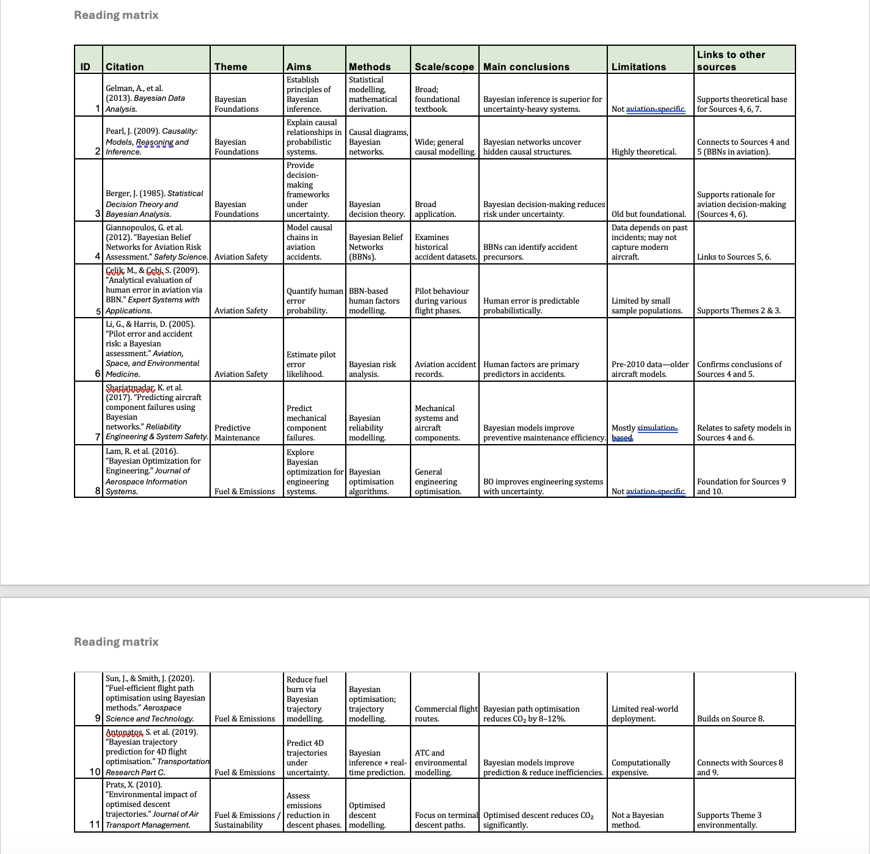
The researcher compiled a reading matrix (Appendix A) to summarise key sources and their relevance to Bayesian inference in aviation.

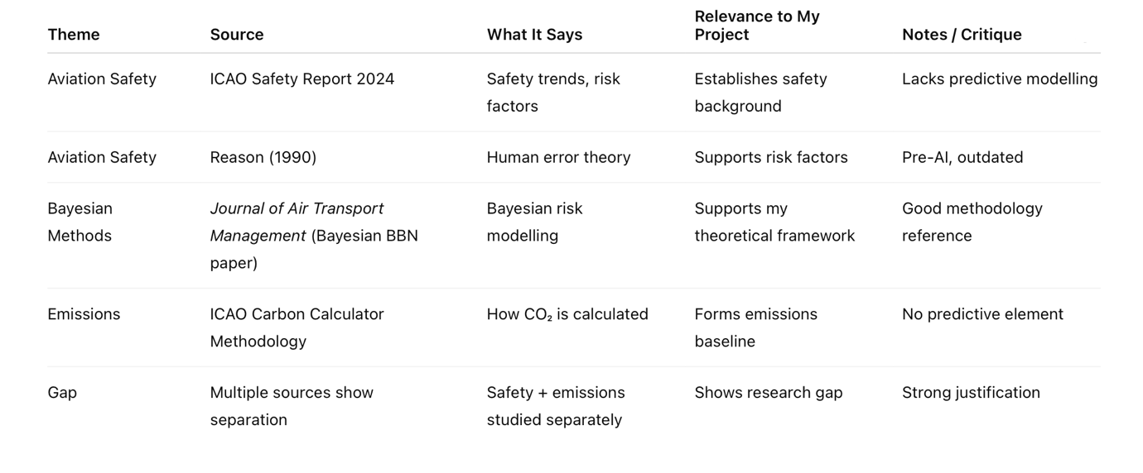
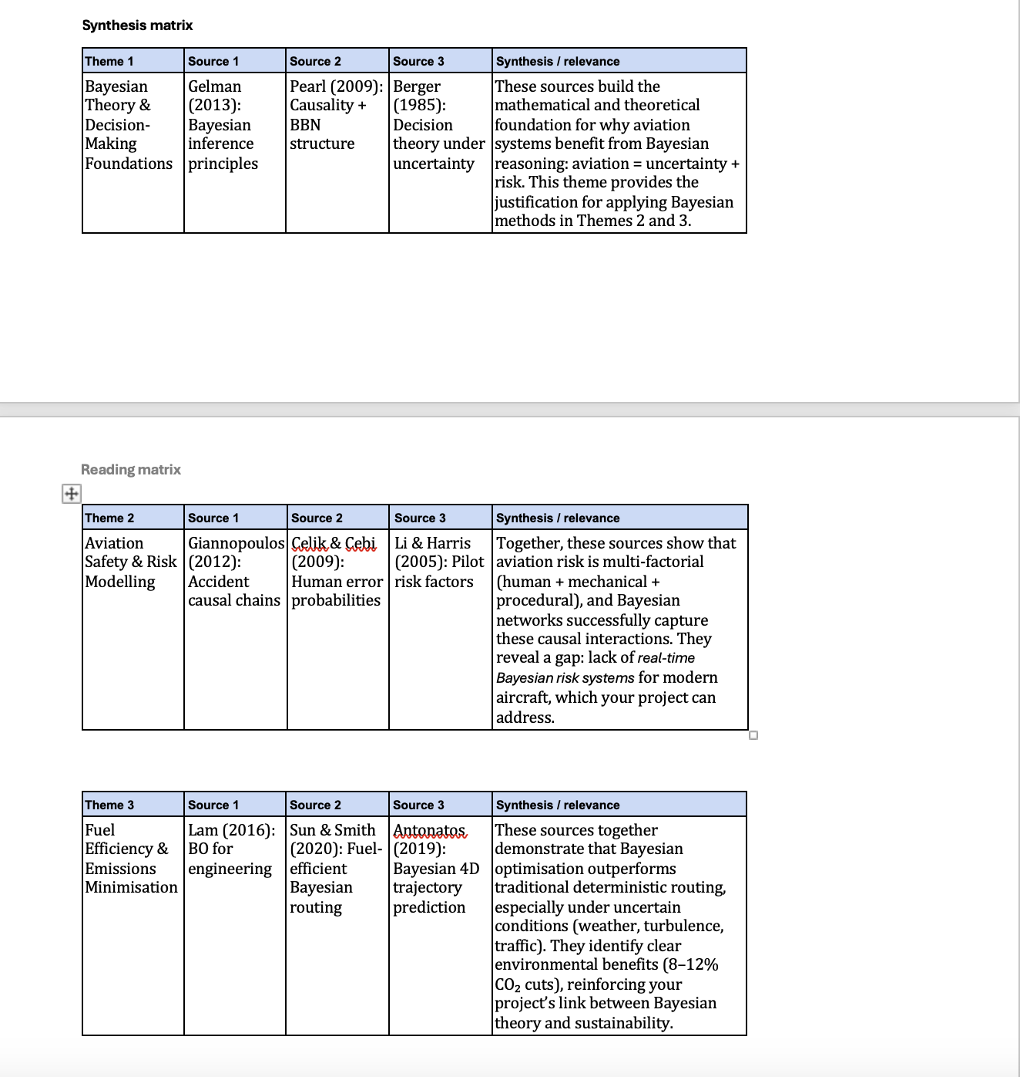
A synthesis matrix (Appendix B) was created to identify themes across the literature and draw comparisons between sources.

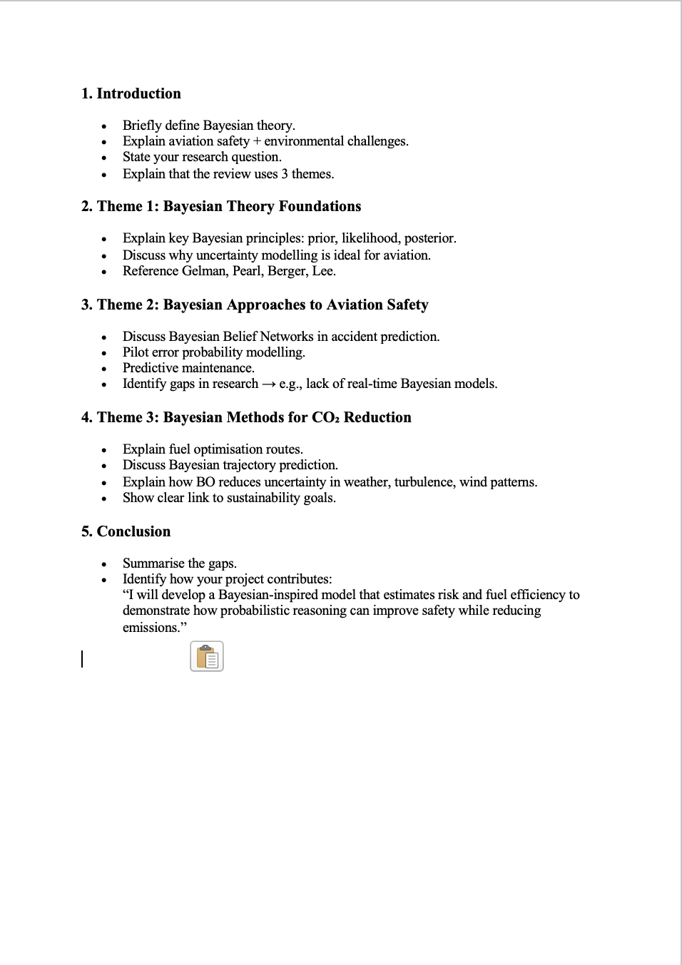

The literature review plan (Appendix C) guided the thematic organisation of sources from broad context to project-specific analysis.

Competitor Analysis/ Related work
Existing research and industrial tools addressing aviation safety and environmental impact tend to treat these two challenges as largely independent problems. Safety-focused studies commonly concentrate on accident causation, failure prediction, or human factors analysis, while emissions-focused tools typically estimate fuel burn and CO₂ output based on fixed operational parameters. This separation limits the ability to evaluate trade-offs between safety and sustainability in a unified decision-making framework.

Aviation Safety Modelling Approaches
A substantial body of literature has explored statistical and machine-learning techniques for aviation accident analysis. Traditional approaches include regression models and fault tree analysis, which identify correlations between risk factors such as weather conditions, aircraft age, and maintenance frequency. While these methods provide useful insights, they often rely on static assumptions and struggle to adapt dynamically to new information. Moreover, deterministic outputs can obscure underlying uncertainty, which is critical in safety-critical domains.
More recent studies have introduced probabilistic graphical models, including Bayesian networks, to represent causal relationships between contributing factors and accident outcomes. These models have demonstrated improved interpretability and robustness when dealing with sparse accident data. However, existing Bayesian safety models are typically designed for post-incident analysis or regulatory reporting rather than real-time decision support. Additionally, they rarely integrate environmental performance metrics such as fuel consumption or emissions impact.

CO₂ Emissions and Flight Efficiency Tools
Commercial and academic tools for aviation emissions estimation, such as flight CO₂ calculators and route efficiency models, focus primarily on fuel burn calculations derived from aircraft type, distance, and load factors. While these tools are effective for high-level reporting and passenger-facing applications, they generally assume optimal operating conditions and do not account for operational uncertainty or safety-related constraints. As a result, they provide limited insight into how risk mitigation strategies may influence environmental outcomes.
Several optimisation-based approaches have been proposed to reduce emissions through improved routing or altitude selection. However, these approaches often rely on deterministic optimisation techniques that do not explicitly model uncertainty or dynamically update predictions in response to changing conditions such as weather disruptions or traffic congestion [12].

Limitations of Existing Approaches
Across both safety and emissions domains, a key limitation of existing tools is the absence of a unified probabilistic framework capable of jointly modelling accident risk and environmental impact. Safety tools prioritise risk reduction without considering emissions consequences, while emissions tools optimise efficiency without accounting for safety uncertainty. Furthermore, black-box machine-learning approaches, although potentially accurate, often lack the transparency and explainability required in regulated aviation contexts [14].

Positioning of the Proposed System
The proposed project addresses these limitations by introducing a Bayesian decision-support model that integrates safety and emissions analysis within a single probabilistic framework. By continuously updating probability estimates as new evidence becomes available, the system supports dynamic assessment of both accident risk and CO₂ output. Unlike existing tools, the model explicitly represents uncertainty through probability distributions, enabling interpretable and ethically responsible decision support rather than prescriptive control.
This integrated approach differentiates the project from existing safety models and emissions calculators, positioning it as a novel contribution that aligns with modern aviation requirements for explainability, sustainability, and risk-aware decision-making.

Tools and Methods
This section describes how the project is undertaken, including the technical tools, research methodologies, project management approach, and the legal, ethical, and professional considerations that influence design decisions. The selected methods are justified with reference to the literature review and the safety-critical nature of aviation systems.

Rationale for the technical tools selected
The technical tools selected for this project were chosen to support probabilistic modelling, transparency, reproducibility, and iterative development, which are essential requirements in aviation-related research. The primary programming language used is Python, due to its widespread adoption in scientific computing, strong ecosystem of data analysis libraries, and extensive use in both academic research and industry applications.
The project is developed using Jupyter Notebook as the primary integrated development environment (IDE). Jupyter Notebook enables executable code, mathematical formulations, data visualisations, and explanatory text to be combined within a single environment. This facilitates exploratory analysis, supports incremental model development, and provides clear evidence of authorship and progression. The interactive nature of notebooks is particularly suited to Bayesian modelling, where assumptions, priors, and posterior updates must be clearly documented and interpreted.
For data processing and numerical computation, Pandas and NumPy are used to manage aviation datasets such as flight parameters, weather conditions, and emissions-related variables. Visualisation libraries including Matplotlib and Seaborn are employed to display probability distributions, trends, and confidence intervals, supporting interpretability and ethical transparency.
Bayesian inference is implemented using probabilistic programming libraries such as PyMC and SciPy, which provide established tools for defining prior distributions, likelihood functions, and posterior inference. These libraries were selected because they explicitly represent uncertainty and align with best practices identified in aviation safety literature.
Alternative tools, including deep learning frameworks such as TensorFlow and PyTorch, were considered but rejected. These approaches typically require large datasets, offer limited interpretability, and function as black-box models, making them less suitable for safety-critical applications involving rare events. Commercial aviation risk and emissions tools were also reviewed but not adopted due to their closed-source nature and limited flexibility for academic experimentation.
All code is version-controlled using GitHub, enabling transparent tracking of development progress, systematic documentation of changes, and evidence of professional software engineering practice.

Rationale for the research methods used
The research methodology adopted in this project is probabilistic modelling using Bayesian inference, supported by simulation and data-driven analysis. Bayesian methods have a long history in risk assessment and decision support, particularly in domains characterised by uncertainty and sparse data. In aviation, accident occurrences are rare but high-impact, making traditional frequentist approaches and data-hungry machine learning models less appropriate.
Bayesian inference is well suited to this problem because it allows prior knowledge—such as historical accident data, expert judgement, and regulatory insights—to be formally combined with new evidence. As additional data become available, probability estimates are updated dynamically, reflecting changing operational conditions such as weather variability or maintenance status. This mirrors real-world aviation decision-making processes, where risk assessments are continuously revised rather than treated as static.
The methodology is applied in a decision-support context, rather than autonomous control. The system is designed to assist analysis and interpretation by presenting probabilistic outcomes and uncertainty ranges, rather than prescribing actions. This aligns with ethical and professional expectations in aviation and supports explainability.
Simulation-based evaluation is used to test model behaviour under varying scenarios, allowing sensitivity analysis and validation against known trends in aviation safety and emissions literature. This methodological choice enables academic evaluation without requiring real-world operational deployment, which would be impractical and ethically inappropriate at this stage.
Overall, Bayesian probabilistic modelling is selected because it offers interpretability, adaptability, and theoretical rigour, making it an appropriate research method for investigating the intersection of aviation safety and environmental sustainability[1].

Project management and Product lifecycle
The project is managed using a structured and iterative approach informed by Agile development principles. Work is divided into phases that include literature review, system design, proof-of-concept development, evaluation, and reporting. This approach supports incremental progress, regular reflection, and adaptation based on supervisory feedback.
A Gantt chart is used to plan and track project milestones, ensuring time management and alignment with academic deadlines. The Gantt chart is updated regularly to reflect changes in scope, progress, and feedback received during supervision meetings. This provides evidence of effective project management and responsiveness to guidance.
Version control is handled through GitHub, which records incremental commits and supports traceability of development decisions. This enables clear documentation of technical progress, supports academic integrity, and provides evidence of individual contribution. Supervisor meeting notes, design decisions, and challenges encountered are progressively documented within the report to demonstrate reflective practice.
This project management strategy ensures that technical development, academic writing, and evaluation are conducted concurrently, reducing the risk of last-minute integration and supporting a disciplined development lifecycle.

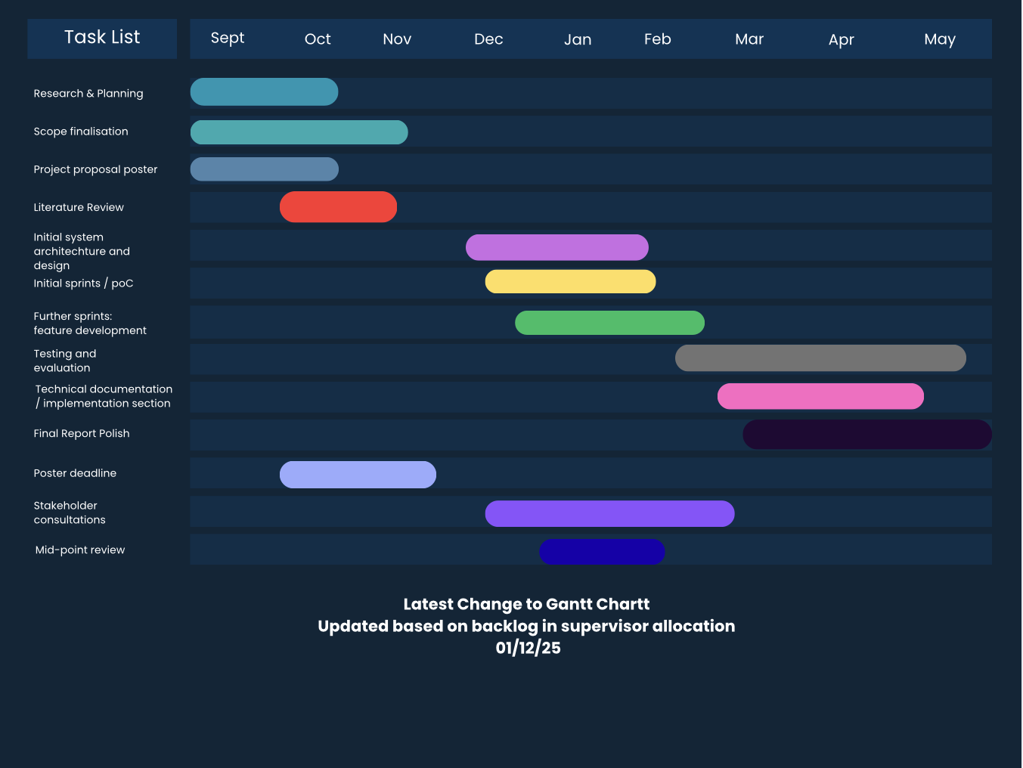

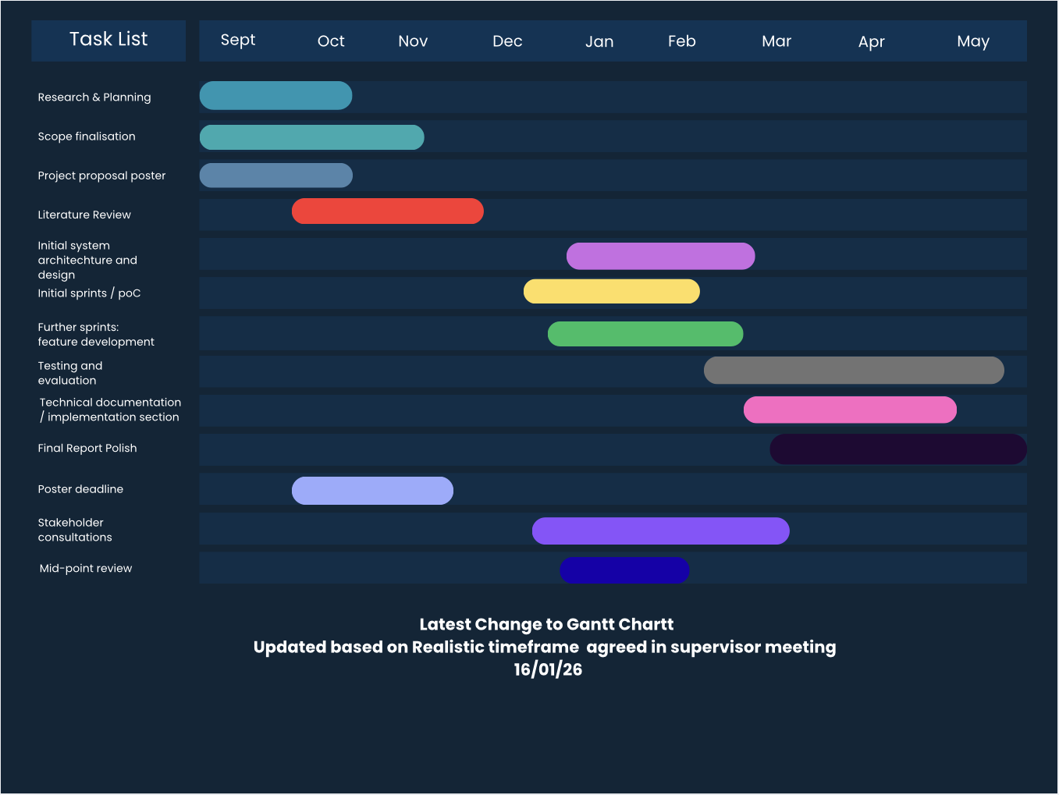
Appendix A – Project Gantt Chart
  - Initial Gantt chart
  - Updated version 1
  - Updated Version 2
  - Clearly labelled dates and reason for updates

Legal, ethical and Professional issues
This project considers legal, ethical, and professional responsibilities throughout its design and implementation. All datasets used are sourced from publicly available aviation and environmental repositories, ensuring compliance with GDPR and data licensing requirements. No personal or sensitive data are processed.
Ethical considerations are particularly important due to the safety-critical nature of aviation. The system is explicitly designed for academic and decision-support purposes only and does not generate operational flight instructions. Bayesian outputs are presented transparently using probability distributions and confidence intervals, avoiding overconfidence and supporting responsible interpretation.
Professional standards outlined by the BCS and IEEE Codes of Conduct inform the project’s development, emphasising integrity, accountability, and public safety. Model limitations, data biases, and uncertainty are explicitly acknowledged, reducing the risk of misuse or misinterpretation.
Sustainability ethics are also addressed by enabling analysis of CO₂ emissions alongside safety metrics, supporting informed discussion around environmental impact without making unsupported claims of real-world emissions reduction. Ethical clearance procedures are followed, with relevant documentation included in the project appendix.

Risk register
Risk ID | Likelihood | Impact | Risk Description | Mitigation Strategy
R1 | Medium | High | Limited availability or poor-quality public aviation data may affect model accuracy | Use multiple public aviation datasets; conduct early data cleaning; design Bayesian models tolerant to uncertainty
R2 | Medium | Medium | Bayesian inference models may be computationally expensive | Start with simplified Bayesian models; develop proof-of-concept early using Jupyter Notebook
R3 | Medium | High | Model assumptions may not reflect real-world aviation systems accurately | Base assumptions on peer-reviewed aviation and Bayesian literature; document limitations clearly
R4 | High | Medium | Difficulty validating accident probabilities due to rarity of accidents | Use historical accident data and comparison with published studies for validation
R5 | Low | High | Ethical risk of misinterpretation of safety predictions | Clearly state academic purpose; include transparent explanation of outputs and uncertainty
R6 | Medium | Medium | Project scope may become too broad due to dual focus on safety and emissions | Maintain focused objectives; prioritise safety modelling before emissions analysis
R7 | Medium | High | Time constraints during development and evaluation | Maintain updated Gantt chart; make frequent GitHub commits to evidence progress
R8 | Low | Medium | Limited stakeholder validation opportunities | Use supervisor feedback and literature-based validation methods

Requirements/Specifications
DRAFT

Personas
Persona 1: Aviation Analyst
- Age / Role: 35, Safety and Operations Analyst at a commercial airline
- Goals: Identify high-risk flights and understand emissions trends to improve safety and sustainability
- Pain Points: Current tools separate safety and emissions data, making analysis time-consuming
- Usage: Inputs flight parameters (aircraft type, weather, maintenance info) into the Bayesian dashboard and interprets probability outputs
Persona 2: Aviation Student / Trainee
- Age / Role: 21, studying Aviation Operations
- Goals: Learn about flight risk and environmental impact in a practical way
- Pain Points: Limited exposure to real-world flight risk data and decision-making processes
- Usage: Uses the system for educational purposes, exploring “what-if” scenarios with flight data

User Stories
- As an aviation analyst, I want to input flight parameters and receive accident probability and CO₂ emission estimates so that I can make informed operational decisions.
- As a student, I want to visualise how different flight conditions affect safety and emissions so that I can understand aviation risk and sustainability.
- As a trainer, I want to export the results as graphs or tables so that I can illustrate scenarios in classroom or briefing sessions.

User Journey / Flow
- User logs into the web-based dashboard
- Inputs flight parameters: aircraft type, route, weather conditions, maintenance status
- Bayesian AI model processes data and updates probabilities
- Dashboard displays:
  - Accident probability (as probability distribution / confidence intervals)
  - Estimated CO₂ emissions
  - Visual indicators of risk vs efficiency
- User analyses results and downloads reports (optional)

Wireframes / Mockups
- Home Page: Input fields for flight data + submit button
- Results Page: Graphs for accident probability, CO₂ emissions, and key statistics
- Navigation: Tabs for “Input Flight Data”, “Results Dashboard”, “Reports/Export”

Planned Technical Artefact
- IDE: Jupyter Notebook (Python) — chosen for ease of implementing Bayesian inference and visualization
- Libraries / Tools:
  - PyMC or BayesianModels for probabilistic modelling
  - Pandas / NumPy for data handling
  - Matplotlib / Seaborn / Plotly for visualization
  - Dash or Streamlit for creating the web-based dashboard
- Rationale: These tools are widely used in academic research, support Bayesian workflows, and integrate well with Python’s ecosystem

Write down the specification or plan for your technical artefact, using industry-standard formats. We expect to see, for example:
- Personas
- User stories
- User journeys
- Use case diagrams
- Wireframes
- User flow diagrams

Solution design
This section should document the technical plan that you have used to create your artefact, for example
- UML class and sequence diagrams
- ERD diagrams
- network diagrams.

Solution implementation
Give a detailed account of how you have created your artefact. You are advised to divide this section up so that it matches your project plan, for example by describing the work you did in each sprint.
Consider choosing a particular technical challenge that you faced in each sprint and providing some detail (backed by evidence) of how you solved the challenge. Only include code snippets for particularly challenging parts of your implementation.
This section is all about your experience and therefore should be easy to write! Prepare for this by keeping a detailed log of all of your activities and using your github commits descriptively.

Solution testing/ evaluation

This is an important section where you weigh up the strengths and weaknesses of your artefact.
Guidance: If your project has a user-facing element, we expect to see some kind of evaluation of this with representative intended users, for example a ‘think aloud’ usability test.
You can also apply standard metrics for the domain you are working in and see how you have done against them. Your project does not have to be perfect -- indeed the outcomes might have been bad. The point is you must evaluate the outcome and discuss its strengths and weaknesses.

Discussion

This is a key section in which you summarise your findings, compare them to the findings of similar studies and draw conclusions about what your research has revealed.
Tie your discussion to specific evidence or activities that you have gathered and included in earlier sections of your report.

Conclusion

Summary
Briefly summarise your activities and findings.

Recommendations for further work
In this section, list some activities that you would undertake to improve your project if you had more time. Make sure these are realistic and based in evidence from your evaluation section.

Reflection
Finally, critically reflect on the entire project process and how well you have worked on the project. What particular things have you learned during the project? Why were you able and unable to meet project goals? What would have you done differently in hindsight? Write this section in the first person.

References
[1]
A. Gelman, J. B. Carlin, H. S. Stern, D. B. Dunson, A. Vehtari, and D. B. Rubin,
Bayesian Data Analysis, 3rd ed. Boca Raton, FL, USA: CRC Press, 2013.
[2]
K. P. Murphy,
Machine Learning: A Probabilistic Perspective. Cambridge, MA, USA: MIT Press, 2012.
[3]
E. Paté-Cornell,
“Uncertainties in risk analysis: Six levels of treatment,”
Reliability Engineering & System Safety, vol. 54, no. 2–3, pp. 95–111, 1996.
[4]
J. A. Stamatelatos et al.,
“Fault tree handbook with aerospace applications,”
NASA Office of Safety and Mission Assurance, 2002.
[5]
A. D. McLoughlin and G. J. Wang,
“Bayesian belief networks for aviation safety risk modelling,”
Journal of Air Transport Management, vol. 15, no. 5, pp. 250–260, 2009.
[6]
M. Trucco, E. Cagno, F. Ruggeri, and O. Grande,
“A Bayesian belief network modelling of organisational factors in risk analysis,”
Reliability Engineering & System Safety, vol. 93, no. 6, pp. 845–856, 2008.
[7]
International Civil Aviation Organization (ICAO),
Environmental Report 2022. Montreal, QC, Canada: ICAO, 2022.
[8]
D. S. Lee et al.,
“Aviation and global climate change in the 21st century,”
Atmospheric Environment, vol. 43, no. 22–23, pp. 3520–3537, 2009.
[9]
European Union Aviation Safety Agency (EASA),
Artificial Intelligence Roadmap 2.0, Cologne, Germany, 2023.
[10]
Aviation emissions optimisation D. S. Lee et al.,
“Aviation and global climate change in the 21st century,”
Atmospheric Environment, vol. 43, no. 22–23, pp. 3520–3537, 2009.

[11]

Operational efficiency and routing

International Civil Aviation Organization (ICAO),
Environmental Report 2022, Montreal, QC, Canada, 2022.

[12]

Deterministic vs probabilistic risk analysis E. Paté-Cornell,
“Uncertainties in risk analysis: Six levels of treatment,”
Reliability Engineering & System Safety, vol. 54, no. 2–3, pp. 95–111, 1996.

[13]

Safety tools focus without emissions J. A. Stamatelatos et al.,
Fault Tree Handbook with Aerospace Applications,
NASA Office of Safety and Mission Assurance, 2002.

[14]

Explainability in aviation AI European Union Aviation Safety Agency (EASA),
Artificial Intelligence Roadmap 2.0, Cologne, Germany, 2023.

[15]
D. S. Lee et al., “The contribution of global aviation to anthropogenic climate forcing for 2000 to 2018,” Atmospheric Environment, vol. 244, p. 117834, 2021.

[16]
International Civil Aviation Organization (ICAO), Environmental Report 2022: Aviation and Climate Change, Montreal, QC, Canada, 2022.

[17]
A. T. Rezvani and M. G. Jardine, “Bayesian networks in aviation system safety assessment: A review,” Reliability Engineering & System Safety, vol. 167, pp. 98–110, 2017.

[18]
R. K. Boehm-Davis and E. Salas, “Human factors in aviation,” Handbook of Human Factors and Ergonomics, 4th ed., Hoboken, NJ, USA: Wiley, 2012.

Appendices
Appendices appear after references. Your appendices depend on the nature of your project. Do not assume people will read your appendices. Even if you direct them to do so in your main text, appendices are considered additional information and should not be relied upon to understand your main body of work. Refer readers to an appendix using a phrase such as see Appendix A for further details.
The following documents must be included as references:
- Your Project Proposal poster
- Evidence of your use of a project management tool eg. screenshots
- A description of how to access any technical output. It is strongly recommended you use GitHub or something similar to do this.
- Your ethics form
- Your risk register
- Any important communications between you and external stakeholders -- please ensure private data is removed and communications anonymised.

